**12 Oct 2018** **The Weekly Bulletin of Rotary Club of Kathmandu Mid-Town** **bc-6.10/018**

|  |
| --- |
| C:\Users\Public\Documents\RIP T1819_EN.png |

District: 3292 Web:www.rotarymidtown.org.np Club Id: 26776

**OCTOBER IS ECONOMIC AND COMMUNITY DEVELOPMENT** **MONTH**

**Economic and community development is one of Rotary’s six areas of focus.**

Rotary supports investments in people to create measurable and enduring economic improvement in their lives and communities.

The Rotary Foundation enables Rotarians to invest in people by creating sustainable, measurable and long term economic improvements in their communities and livelihoods by:

1. Building the capacity of entrepreneurs, community leaders, local organizations, and community networks to

support economic development in impoverished communities;

2. Developing opportunities for productive work;

3. Reducing poverty in under-served communities;

4. Supporting studies for career-minded professionals related to economic and community development.

**Club Meeting # 1460** : 5 Oct 018

Guest speaker Shilshila Acharya, CEO of Himalayan Climate Initiative:

after her presentation on Finding Sustainable Solutions in Nepal, in fellowship with club members.

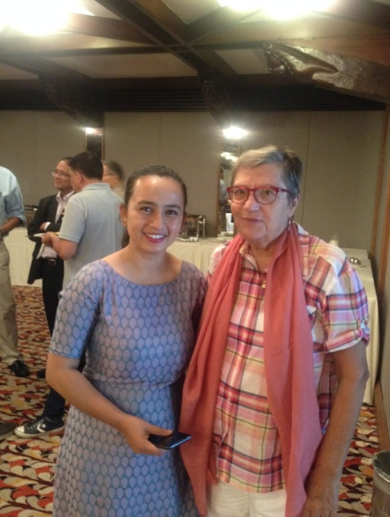 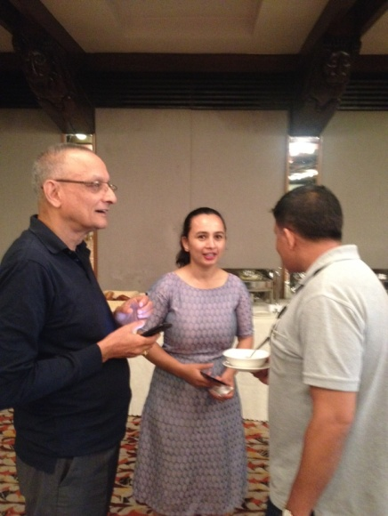 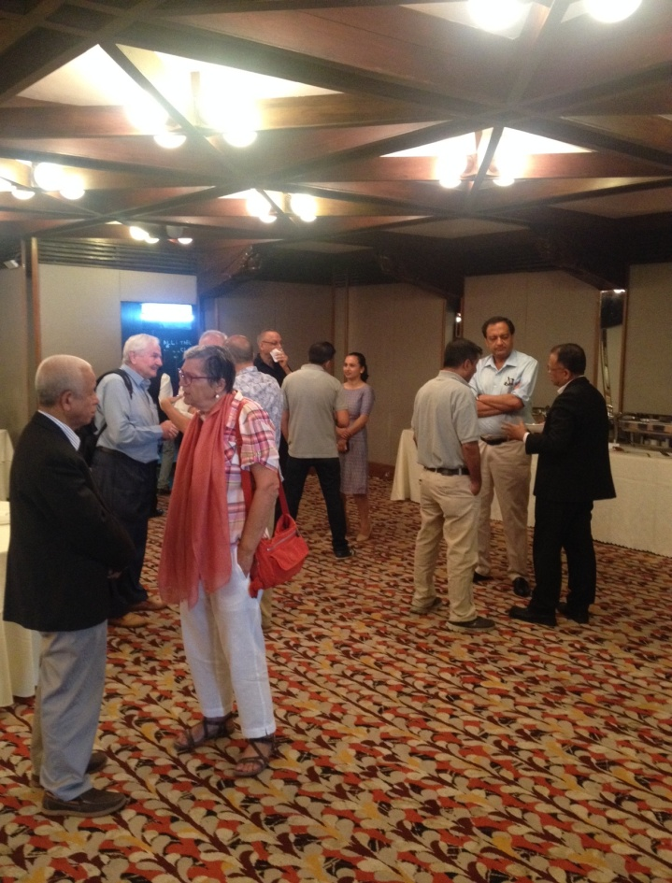

*Photo courtesy: Rtn Shyam R Thapalia*

HCI through its Social Innovation and Business Incubation Hub in Kathmandu and Nepalgunj roll out 12 socially minded start-ups aligned to its three pronged strategies.

Educate, encourage and inspire the youth to make them see and appreciate the ‘Case for Sustainability.’

Demonstrate: Innovate and get the youth to run smart and entrepreneurial solutions to address social, environmental and economic ills of the society.

Advocate for sustainable and zero carbon growth trajectory adopted by the private sector and the government of Nepal.

**Rotary Pins to Board Members**

PP Mani Joshi provided President pin to President Jo and President Jo provided Rotary pin to 2018-19 Board members present during the meeting:

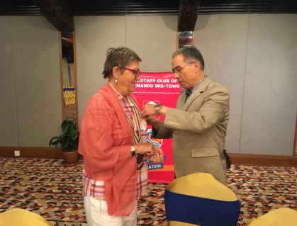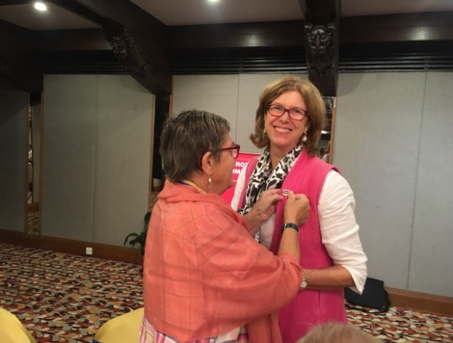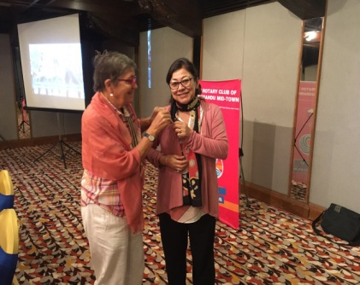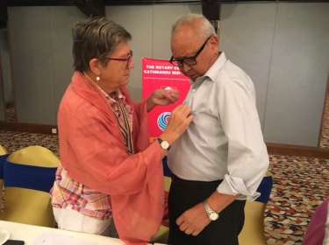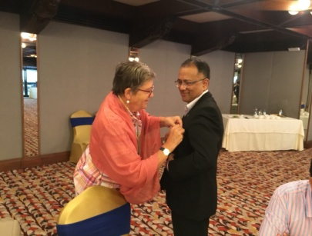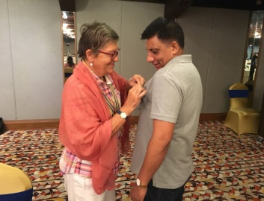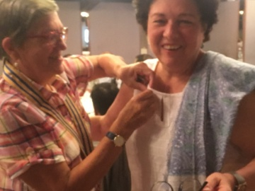

# Weekly Meeting/Program Schedule:

|  |  |  |
| --- | --- | --- |
| Date | Program/ Speaker | Topic of Presentation |
| 12 October | PP Komal B Chitracar | Financial Statement of 2017/18 |

Friday Meeting: 12 Oct

PP Komal Chitracar will give a presentation on financial statement of the year 2017-18 along with the audit report

**HAPPY DASHAIN:**

**On the auspicious occasion of**

**HAPPY VIJAYA DASHAMI 2075**

***May Almighty Goddess Durga Bhawani***

**bestow Her *blessings* to all**

**for good understanding, peace and happiness.**

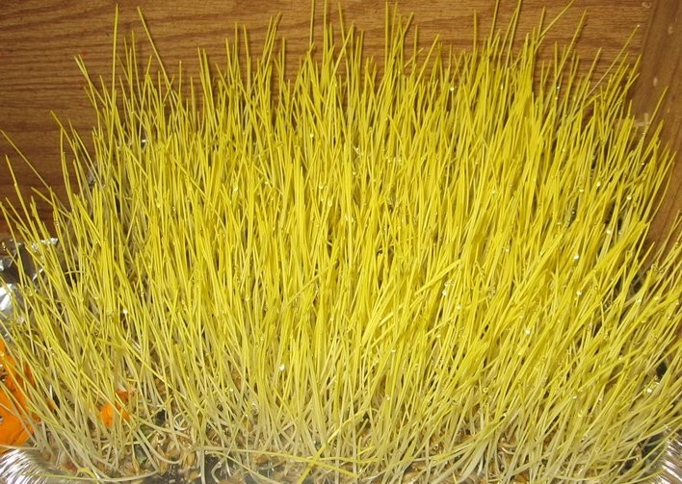

Dashain is a festival that is celebrated commemorating the victory of good over evil.

Dashain is celebrated in memory of a bloody battle between Goddess Durga and demon Mahishasur. As the demon had created troubles for humankind, the Goddess fought with him for nine days in Her nine different incarnations. But it was on the 10th day, She got victory over the demon. And this 10th day is the day of Vijaya Dashami Tika.

Starting from the day of Ghatasthapana different incarnations of Goddess Shakti are worshipped:

The first day: Goddess Shailaputri, 2nd day : Goddess Brahmacharini, 3rd day : Goddess Chandraghanta,

4th day : Goddess Kushmunda, 5th day : Goddess Iskandamata, 6th day : Goddess Katyani,

7th day : Goddess Kalaratri, 8th day : Goddess Mahagauri, and 9th day : Goddess Siddhidatri.

**A THOUGHT FOR TODAY:**

“**A leader is one who knows the way, goes the way, and shows the way.”**

*John C. Maxwell*

**Committee Chairs’ Column:** *(This column is for use by chairpersons of 5 permanent committees: Club Administration, Membership, Public Relations, Service Projects, and the Rotary Foundation)*

**Members’ Corner:** *(This column is for Club members to express anything they would like in matter of Club activities, Club administration, Club issues or on Breakfast Chatter, or on anything else that would be of interest to fellow members.)*

.

**Do you know?**

Our most recent research tells us that the public still doesn’t have a true understanding of what Rotary stands for, how we’re different, why we matter, or the impact we make. They don’t know what we do in local communities or what role we’ve played in the effort to end polio. And nearly 60 percent of those surveyed said they were unaware that a Rotary club exists in their own community.

*Source: Rotary.org*

On Lighter Side:

A blonde tried to sell her old car, but was having problems getting rid of it because the vehicle had been driven 250,000 miles. She discussed her problem with a brunette co-worker at the Salon Shop. The brunette mentioned that she knows of a procedure to make the car easier to sell, but it's illegal to do so. "That doesn't matter," replied the blonde, "if I can just sell the car."

"Okay," said the brunette. "Here is the address of a friend of mine who owns a car repair shop. Tell him I sent you, and he will turn the counter in your car back to 50,000 miles. Then you should be able to unload the car."

The following weekend, the blonde went to see the co worker's mechanic to have the work done.

Several weeks went by before the brunette asked the blonde, "Did you sell your car?"

"No," replied the blonde, "why should I? It only has 50,000 miles on it."

One of our challenges in Rotary is our Council on Legislation. We meet every three years to

consider changing Rotary’s governing policies, but it takes more like four and a half or five years to

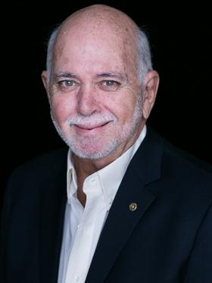

accomplish this because of the deadlines to propose legislation. The world is changing far too fast

for that. We need a way to make major decisions that affect the organization on a quicker basis.

One way would be to conduct those meetings electronically every year. It would be a challenge

because it’s hard to have a dynamic debate online, but I think Rotary is smart enough to figure out

how to do that.

**RI President Barry Rassin**

Please send information on club activities, progress reviews on service projects, relevant photos etc to:

BC Editor: RR Shrestha email: rryesrr@gmail.com

## 12 Oct 2018 The Weekly Bulletin of Rotary Club of Kathmandu Mid-Town bc-6.10/018